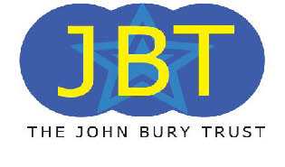 | 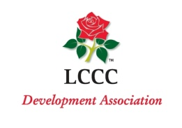

Weekly Lottery Draw

Information

The John Bury Trust has joined forces with Lancashire Cricket Club Development Association to bring you our weekly lottery draw and this is how it works.

By signing up to the lottery, your payment (either by cheque or direct debit) will be taken and you will be issued with the number of entries that you have chosen. The minimum is 10 numbers at £1 per week.

You will receive your acceptance pack through the post with your numbers. Once you receive the pack your numbers will be entered into the weekly draw.

Each week approximately 25 winners are drawn with the main prize being £1000 followed by a number of smaller prizes.

By signing up to the lottery, 50% of your weekly payment comes directly to the John Bury Trust so for every 100 people signed up we would earn £2,500 per year. This money would be used by the Trust to benefit the young people within the Borough of Blackburn with Darwen.

Just £1.00 per week and the chance to win £1000 whilst helping a great cause!
What are you waiting for??

Assisting in the development of young people within the Borough of Blackburn with Darwen

Help JBT carry on with their work by signing up
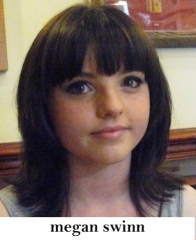
The John Bury Trust issues funding to more than 16 young people each year to enable them to develop mentally or physically
Singer and Dancer

“To promote the mental, moral and physical development and improvement of young people between the ages of ten and twenty five years through the provision of financial assistance so as to develop their full capacities and enable them to become responsible members of society and so that their conditions of life may be improved”.

